

Department | FED
Subject | DSA-2
Academic Year | I-III Semester (2025-26)
Faculty Name | Dr. Sreeram Murthy
Student Name | P.Harsha Vardhan
Roll Number | 2520090180
Branch | CSIT
Course Outcome | CO4

Case Study Topic : Uber Driver Dispatch with Negative-Edge Surge Incentives Using Bellman-Ford Algorithm
Work Done Summary
In this case study, we analyzed Uber's driver-dispatch optimization system. The system models a road network consisting of seven zones:
IND, KOR, MGR, HSR, BTM, JPN, EC
The objective is to route a driver currently located at Indiranagar (IND) to the destination zone EC while minimizing travel cost.
Unlike traditional shortest-path problems, some routes contain negative weights because Uber offers surge incentives for passing through low-demand pickup zones.
The negative-weight routes are:
KOR → BTM = -5
HSR → JPN = -3
Because negative edges are present, Dijkstra's algorithm cannot be safely applied. Therefore, the Bellman-Ford algorithm is used since it correctly handles negative edge weights and also detects negative cycles.
The graph contains seven vertices and ten directed edges.
The objective is:
Find shortest path from IND to EC
Verify absence of negative cycles
Reconstruct optimal route

1. Case Study Problem Explanation
Graph Representation
The weighted edges are:
Edge | Weight
IND → KOR | 8
IND → HSR | 5
KOR → MGR | 7
KOR → BTM | -5
HSR → BTM | 6
HSR → JPN | -3
MGR → BTM | 4
MGR → EC | 10
BTM → EC | 8
JPN → EC | 14

(a) Bellman-Ford Iteration Analysis
Source:
IND
Initial Distance Array:
Zone | Distance
IND | 0
KOR | ∞
MGR | ∞
HSR | ∞
BTM | ∞
JPN | ∞
EC | ∞

Iteration 1
Relax all edges.
Results:
IND → KOR = 8
IND → HSR = 5
KOR → MGR = 15
KOR → BTM = 3
HSR → JPN = 2
HSR → BTM = 11 (ignored because 3 is better)
BTM → EC = 11
Distance Table:
Zone | Distance
IND | 0
KOR | 8
MGR | 15
HSR | 5
BTM | 3
JPN | 2
EC | 11

Iteration 2
Relax every edge again.
No shorter path is discovered.
Distance Table:
Zone | Distance
IND | 0
KOR | 8
MGR | 15
HSR | 5
BTM | 3
JPN | 2
EC | 11

Iteration 3
No changes.
Zone | Distance
IND | 0
KOR | 8
MGR | 15
HSR | 5
BTM | 3
JPN | 2
EC | 11

Iteration 4
No changes.

Iteration 5
No changes.

Iteration 6
No changes.

Bellman-Ford Convergence Analysis
The algorithm converges after:
Iteration 2
This means all shortest paths have already been discovered before completing the required V−1 passes.
Therefore:
Early termination is possible.
The graph contains:
No negative cycle.

(b) Shortest Path Reconstruction
Final Distances:
Zone | Distance
IND | 0
KOR | 8
MGR | 15
HSR | 5
BTM | 3
JPN | 2
EC | 11

Backtracking from EC
For EC:
dist(BTM)+weight(BTM,EC)
=
3+8
=
11
=
dist(EC)
Therefore predecessor:
EC ← BTM

For BTM:
dist(KOR)+weight(KOR,BTM)
=
8+(-5)
=
3
=
dist(BTM)
Therefore predecessor:
BTM ← KOR

For KOR:
dist(IND)+weight(IND,KOR)
=
0+8
=
8
=
dist(KOR)
Therefore predecessor:
KOR ← IND

Final Shortest Path
IND → KOR → BTM → EC
Total Cost:
8 + (-5) + 8
=
11

Does the Path Use Negative Edges?
Yes.
The shortest route contains:
KOR → BTM = -5
This negative incentive reduces total travel cost.
Because Bellman-Ford correctly supports negative weights, it successfully identifies this route.

OUTPUT:
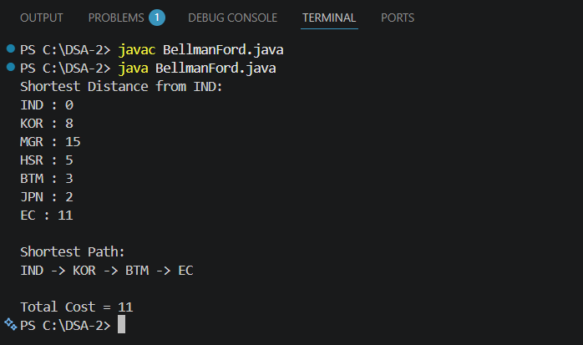

Time Complexity Analysis
Bellman-Ford:
Outer Loop = V−1
Inner Loop = E
Therefore:
O(V × E)

Early Termination Benefit
When no distance changes during an iteration:
Algorithm terminates immediately.
This reduces unnecessary relaxations.
In this graph:
Convergence occurs after iteration 2.
Therefore most remaining iterations are skipped.

Path Reconstruction Complexity
The parent array is followed from target to source.
Length of path = k
Therefore:
O(k)
Worst Case:
O(V)

(d) Importance of Negative-Cycle Detection
Even though Uber's preprocessing confirms that no negative cycles exist, runtime validation remains essential.

Scenario 1: Real-Time Weight Changes
Uber continuously updates:
Travel Times
Surge Incentives
Road Conditions
A previously safe graph may suddenly introduce a negative cycle.
The V-th Bellman-Ford pass detects this because distances continue decreasing indefinitely.

Scenario 2: Software Bugs
Graph-construction bugs can accidentally introduce:
Incorrect edge directions
Duplicate edges
Wrong weights
These defects may create artificial negative cycles.
The V-th pass immediately exposes the issue.

Scenario 3: Integer Overflow
Suppose:
dist[u] + weight
overflows integer limits.
This can produce invalid relaxations and fake shorter paths.
The negative-cycle verification pass helps identify suspicious continued relaxations.

2. Time Complexity and Performance Comparison
Operation | Complexity
Edge Relaxation | O(1)
One Iteration | O(E)
Bellman-Ford | O(VE)
Negative-Cycle Check | O(E)
Path Reconstruction | O(V)

Key Analysis Takeaways
1. Bellman-Ford Correctly Handles Negative Weights
Unlike Dijkstra's algorithm, Bellman-Ford safely processes negative incentive edges.
2. Optimal Route Uses Surge Incentives
The shortest path:
IND → KOR → BTM → EC
benefits from the negative edge:
KOR → BTM = -5
3. Early Convergence Improves Efficiency
The algorithm stabilizes after the second iteration, allowing early termination.
4. Runtime Negative-Cycle Checks Are Essential
Even if preprocessing validates the graph, real-world updates and software errors can introduce new negative cycles.
5. Recommendation
For road networks containing negative incentive edges, Bellman-Ford remains the safest and most reliable shortest-path algorithm because it guarantees correctness while also detecting invalid graph configurations.

GITHUB LINK : https://github.com/harsha-vardhann-reddy/DSA-2-Case-Study

Student Signature | Faculty Signature

